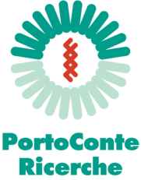 | 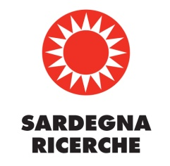

PRESS RELEASE

Summer School on Magnetic Resonance in Food Science
Applications open for the International School which will be held from 1st July to 4th July 2014

Porto Conte Ricerche, with the financial support of Sardegna Ricerche, is organizing the 2014 Summer School on Magnetic Resonance in Food Science.
The course will be held from the 1st to the 4th of July 2014, in Alghero (Italy), at the Porto Conte Ricerche Research Centre.
The course will focus on cutting-edge Magnetic Resonance methodologies, based on both NMR spectroscopy (high-resolution NMR and Time Domain NMR) and Magnetic Resonance Imaging (MRI) techniques applied to food products.
Theoretical lessons and integrated hands-on activities will guide the students through practical and theoretical knowledge on Magnetic Resonance techniques. Frontal lectures, that will be held by international experts (among which Prof Peter Belton, University of East Anglia - UK), will focus on the explanation of theoretical background, description of instruments hardware and software and their uses, data analysis tools, and on their application in food science and food technology through the analysis of case-studies. Moreover, free open seminars will present the state of the art, latest achievements and recent research findings on the application of Magnetic Resonance to food characterization. In laboratory, supported by Porto Conte Ricerche staff, students will learn NMR/MRI data acquisition from food matrices. Obtained data will be then processed and examined according to specific experimental pipelines. Students will be encouraged to provide analytical samples, which are already part of their research. Ideal candidates are young researchers, preferably post graduate students, PhD students and post-doctoral fellows.
In order to attend the event, the registration form must be completed and sent, with the CV, to summerschool@portocontericerche.it by June 1st.
Further information are available on the web site www.portocontericerche.it in the Summer School Section (http://www.portocontericerche.it/servizi/formazione/summer-school/magnetic-resonance-food-science).

Course venue and contacts
Porto Conte Ricerche
S.P. 55 Porto Conte-Capo Caccia Km 8,400
Loc. Tramariglio
07041 Alghero (SS) - Italy
Tel. +39 079 998.400
Fax +39 079 998.567
E-mail: summerschool@portocontericerche.it

